Appetizer

House Appetizers (Egg roll, Crab Cheese Won Ton, BBQ Pork, Fried Prawns) $11.50

Crab Cheese Won Ton (8) $ 8.75 Dumplings (steamed or pan fried) $8.75

BBQ Pork $ 8.50 Fried Won Ton Skin $4.75

Egg roll (1) $ 2.50 Golden Fried Prawns (6) $8.25

Spring roll (2) $ 2.75

Soups

(Add tofu for $1.50 more)

Egg Flower Soup Lg. $7.50 Sm. $3.75 Hot & Sour Soup Lg. $7.50 Sm. $3.75

Won Ton Soup Lg. $7.50 Sm. $3.75 Vegetables Soup Lg. $7.50 Sm. $3.75

Combinations Dinners

Served with Soup and Fortune cookie. Substitution .75 or more

|  |  |  |
| --- | --- | --- |
| #1  Sweet & Sour Pork  Cashew Chicken Chow Mein  Pork Fried Rice  10.50 | #2  Egg Foo Young  Almond Pork Chow Mein  Sweet & Sour Spareribs  10.50 | #3  Pork Chow Mein  Sweet & Sour Chicken  Egg roll  Pork Fried Rice  11.50 |
| #4  Fried Prawns  Egg Foo Young  Sweet & Sour Pork  Pork Fried Rice  11.75 | #5  Fried Prawns  Almond Fried Chicken  Sweet & Sour Pork  Pork Fried Rice  $11.75 | #6  Chicken Chow Mein  Sweet & Sour Prawns  BBQ Pork  Pork Fried Rice.  11.75 |
| #7  Pork Chow Mein  Almond Fried Chicken  BBQ Pork  Egg Roll  Pork Fried Rice  12.25 | #8  BBQ Pork  Sweet & Sour Chicken  Almond Pork Chow Mein  Fried Prawns  Pork Fried Rice  12.25 | #9  Egg Roll  General Tso’s Chicken  Chicken Lo Mein  Pork Fried Rice  12.75 |

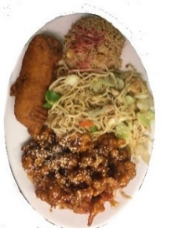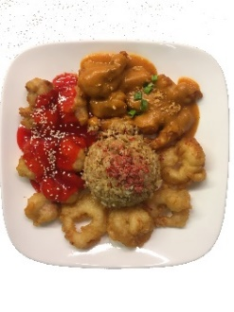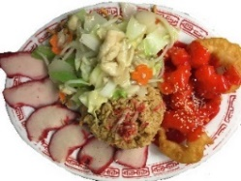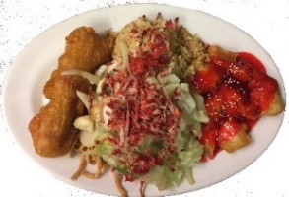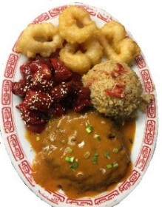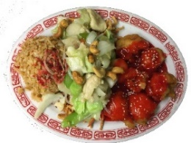

3

9

5

4

1

6